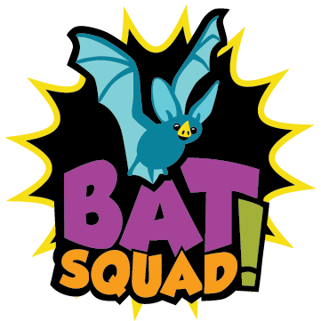

Contact: Sue Smith For Immediate Release
Email: suesmith@yahoo.com

Bat Squad! Amazing Kids Making a Difference for Bats
Eight kids from Northern Lights Middle School are helping spread the message of bat conservation through hands-on projects.

Gladstone, Michigan (October 31, 2016) – Students from Northern Lights Middle School are proving that you don’t need to be an adult to help bats. These kids are members of the “Bat Squad,” a group of young people who are working to protect bats and the environment. Some have created bat-friendly habitat, others have dedicated their science fair projects to bats, and some work to educate their friends, family, and neighbors about the importance of bats. All of these actions can help protect bats living in our community.
Bats consume their body weight in insects each night, making them primary predators of night-flying insects including many crop and forest pests. They are found in every state in the United States and are essential to the environment and economy, especially the agriculture industry. Recent studies have concluded that bats could save farmers up to $53 billion each year in pest control services.
“I think that everyone should know that bats are very beneficial, and that they should not be afraid of them. Bats do a lot of great things for us, and we should protect them,” said Bat Squad Member John Smith.
Despite being so important, bats are in decline nearly everywhere they are found. These amazing animals face a multitude of threats including habitat loss, disturbances while hibernating, pesticide contamination, death from wind turbines, and even intentional killing due largely to fear and misunderstanding. White-Nose Syndrome, one of the greatest threats to bats in North America, is killing bats as they hibernate in caves and mines. The disease has killed over 6 million bats in just 6 years. The economic and environmental consequences of losing so many bats could be devastating.
The Bat Squad is a growing initiative that seeks to raise greater awareness of the importance of bats and what is being done to help them worldwide. By committing to take actions to help bats, you too could become an elite member of this amazing team. “You don’t need super powers to make a difference. By working with classmates and our teacher on a bat project, we were able to join the Bat Squad and be a Bat Hero!” said Bat Squad member Jennie Smith.
Recognizing that bats need a lot of help, Northern Lights Middle School would like to challenge other local schools to take action and complete their own bat conservation projects. “There are a lot of ways to get involved and we would love to see what other students our age can do,” said Jennie. Teachers and students can learn more about how to help bats by visiting the Project EduBat website at: https://batslive.pwnet.org/edubat.

###

